A good business plan can help secure finance, define the direction of the business and create strategies to achieve the owner’s goals. The business plan template steps you through the process of creating a solid, well-structured plan for established and start-up businesses.

Using this template

Before completing this business plan template and starting to use it, consider the following:
- Determine who the plan is for: Will it be used internally to review operations or will third parties be involved? Deciding the purpose of the plan can help you target your answers.
- Determine what sections apply to your business: This template has been designed to review operations for start-up businesses as well as established businesses. Some sections will be more relevant than others, depending on the purpose of your plan. Once you have completed your plan, go through it and delete the sections that you didn’t need.
- Do your research: You will need to make quite a few decisions about your business including structure, marketing strategies and finances before you can complete the template. While researching and evaluating your business you may identify a number of improvement opportunities.
- Use the [italicised text]: The italicised text is there as a guide, providing some more detailed questions you may like to answer when preparing your response.
- Actual versus expected figures: Existing businesses can include actual figures in the plan, but if your business is just starting out and you are using expected figures for turnover and finances, you will need to clearly show that these are expected figures or estimates.
- TaT Biz strategy checklist: Review the strategy checklist to see if there are additional strategies and activities you need to perform to help you achieve your goals and targets. This checklist should act as a guide only and there may be many other strategies that are not included that are specific to your business.

[INSERT YOUR BUSINESS LOGO]

[Your name]
[Your title]
[Business name]
[Main business address]
ABN: [ABN]
ACN: [ACN]

[Business name]
Business Plan

Prepared: [Date prepared]

Table of Contents

Business plan summary 3
Purpose 3
The business 3
Business activity 3
Business premises 3
Product range analysis 3
Registration details 3
Business advisors 4
Licences and registrations 4
Organisation chart 4
Management and ownership 5
Human resources 5
Insurance 6
Risk management 6
Suppliers 6
Trading hours 7
Communication channels 7
Payment types accepted 7
Credit policy 8
Warranties, refunds and guarantees 8
Quality control 8
Memberships and affiliations 8
Environmental plan 8
The market 8
Your customers 8
Area analysis 9
S.W.O.T. analysis 10
Your competitors 11
Pricing analysis 12
Marketing and advertising 12
The future 13
Ultimate goal 13
Three-year goals 13
12 month goals and targets 13
Action plan 14
The finances 15
Key objectives and financial review 15
Start-up or expansion costs for [YEAR] 16
Balance sheet forecast 17
Profit and loss forecast 18
Expected cash flow 19
Break-even analysis 20
Supporting documentation 21

Business plan summary

Purpose

[Explain why you are writing the plan. Is it to secure finance? A management tool? An operational guide for the business?
If the plan is intended to support an application for finance, state the name of the bank or other financier to whom the application is being made, the amount of finance being applied for, the term of the loan and the security you’ll be providing the bank. State what the loan will be used for and how it will be repaid: for example, from additional revenue generated as a result of borrowing the money.]

The business

Business activity

[Provide a concise description of the business, what services it provides and the market in which it operates.]

Business premises
Business location: [Describe the location, zoning, geographical and demographical surrounds, passing vehicle and pedestrian traffic, facilities, fit-out, equipment, parking, size of the space, the condition of the building, how long the business has been there, the area occupied, accessibility and visibility. Do you want to relocate the business? Do you want to renovate or expand? Do you need to improve your street view or presentation? You may wish to include a photograph here, or in the appendix along with a floor plan.]
Buy/lease: [If you own the premises, provide ownership details, current value and any security held over the premises. If you’re leasing, specify the term or duration of the lease, options held, key dates, rent, outgoings and other payments under the lease, rental per square metre, anticipated increases in rent over the term of the lease and the name of the owner and managing agent. If you are still looking for a lease, outline your commercial lease requirements and any utilities/facilities required. Does your lease provide long term security?]

Product range analysis

[Provide details of the products and services your business offers. Are there other areas that you need to expand into? What areas do you see as emerging markets? What areas do you see as shrinking markets? What services are your competitors providing that you don’t?]

Registration details
Business name: [Enter your business name as registered in your state/territory. If you have not registered your business name, enter your proposed business name.]
Trading name(s): [Registered trading name(s)]
Date registered: [Date business name registered]
Location(s) registered: [State(s) in which the business is registered]
Business structure: [Sole trader, partnership, trust, company]
ABN: [Registered Australian Business Number]
ACN: [Registered Australian Company Number if applicable]
GST: [Are you registered for Goods and Services Tax? Date registered?]
Domain names: [Registered internet domain names]

Business advisors
[Potential investors and/or partners will want confirmation that your business is supported by a professional team of qualified advisers such as accountants, solicitors, bankers, insurance brokers and relevant industry associations.
Include the business name and address of each contact along with any professional memberships you hold which may include Chambers of Commerce, various institutes and industry associations.]
Banker:
Accountant:
Lawyer:
Insurance broker:
Industry advisors:
Industry associations:
Key networking contacts:

Licences and registrations
[Provide a list of any licences and registrations that the business holds or needs. If you’re going to expand or diversify, what else are you going to require?]

Organisation chart
[Outline your business structure in the chart below. If you have plans to make staffing changes then you may wish to build an additional chart showing the way you want it to be in the future.]
Mr Jim Roberts
Owner/Manager

Mr John Brown
Service Advisor

Mr Ben Roe
Head Technician

Mr Jim Jones
Technician

Mr Dan South
2nd yr apprentice
Mrs Jan Brown
Part time bookkeeper

Management and ownership
Names of owners: [List all of the business owners.]
Details of management and ownership: [As the owner(s), will you be running the business or will a manager be running the business on your behalf? What will be your involvement? If it is a partnership briefly outline the percentage share, role in the business, the strengths of each partner and whether you have a partnership agreement/contract in place?]
Experience: [If you’ll be using your plan as a tool for obtaining finance or investment, most banks and potential investors will want an assurance that the people responsible for running the business are qualified and competent. What experience do the business owner(s) have? How many years have you owned or run a business? List any previous businesses owned/managed. List any major achievements/awards. What other relevant experience do you have? Don’t forget to attach your resume(s) to the back of your plan.

Human resources

Current staff: [List your current staff in the table below.]

Job title | Name | Time employed | Relevant qualifications, skills and strengths

Staff training: [What training do you as the business owner/manager need to undertake to keep your skills current? Is there any training that your staff require? Are there any jobs/services that only the owner can perform? If you are going to expand or diversify, what training will be required? Are there any technician journals or industry groups that you need to subscribe to? Do you need to run regular internal training?]

Technician profitability analysis: [Double-click the table below to enter details of your technician profit contribution. Are any staff under-performing? Are any staff over-performing? Do you need to make any staffing changes?]
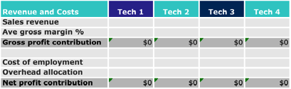

Required staff: [List your required staff in the table below.]

Job Title | Skills necessary | Date required
Apprentice | No specific skills required. Just a good work ethic and a desire to succeed in the industry. | January 2012
Recruitment options: [How do you intend to obtain your required staff – advertising in the local paper, online advertising and recruitment agencies?]

Insurance
[Provide details of the insurance you have or might require. Consider workers compensation, public liability insurance, professional indemnity, product liability, business assets, business revenue and customer vehicle protection]

Risk management

[List the potential risks in the table below (in order of likelihood) that could impact your business. Consider risks such as theft, fire, flood and storm.]

Risk | Likelihood | Impact | Strategy
Description of the risk and the potential impact to your business. | Highly unlikely Unlikely  Likely  Highly likely | High  Medium  Low | What actions will you take to minimise or mitigate the potential risk to your business?

Suppliers

[Who are your main suppliers? What do they supply to your business? Do you expect to encounter shortages or fluctuation in prices? What are their credit terms? What is your buying policy?]

Fixed Assets
Plant and equipment: [List your current plant and equipment. These can include vehicles, hoists, computer equipment and phone lines. If the business has been operating for at least one financial year, include both the cost price and the written down value, which is the cost price less decline in value (often referred to as depreciation). Depending on the purpose of this plan you may prefer to present this information in summary form and attach more detail in an appendix.

If you need more equipment, document the required date and the expected costs.
Equipment | Purchase date | Purchase price | Written down value

Technology (Software): [What technology do you require? For example: website, point of sale software or accounting package? What will be the main purpose for each? Will they be off-the-shelf or purpose built? What is the estimated cost of each technology solution you require?]

Inventory

Inventory holdings: [If you hold significant inventory balances list your current inventory items in the table below. Depending on the purpose of this plan you may prefer to attach a full inventory list to the back of this business plan.]

Inventory item | Unit price | Quantity in stock | Total cost

Inventory control: [Describe the systems you have in place to minimise the loss of stock as a result of theft, damage, loss and accounting errors. Issues to consider include strong internal controls, policies and systems, employee awareness, training and compliance programs and appropriately placed signs and mirrors. If you will be performing an annual stocktake provide details?]

Trading hours
[What are your trading hours? What are your expected peak trading times? Do you have seasonal fluctuations? How do your trading hours accommodate these changes?]

Communication channels
[How will customers get in contact with you? These channels can include: telephone (multiple lines), online enquiries, email, fax, internet blog or social media channel. How will you get in contact with your customers?]

Payment types accepted
[What payment types will you accept. Examples include cash, credit, cheque and Paypal.]

Credit policy
[What is your credit policy for customers? What are your credit terms? What are your collection procedures? Do you have finance options for your customers?]

Warranties, refunds and guarantees
[What is your warranty policy? What is your business refund/exchange policy? What is your business guarantee? Do you have a guarantee on your labour? How do you communicate this to your customers?]

Quality control
[Describe your quality control process. What checks or balances do you have in place to ensure the product or service you offer is produced to the same standard of quality? What steps do you take to meet product safety standards?]

Memberships and affiliations
[Is your business a member of any particular industry association or club? Do you have any affiliations with any other organisation? Are there any memberships or affiliations that you need to join?]

Environmental plan

[Describe the impact your business could potentially have on the environment and community. Are there any government regulations you need to consider? Do you need to perform an environmental audit?
Document what you do or plan to do to minimise the impact of your business on the environment and your community. Remember that many environmentally friendly strategies can save you money and win the approval of clients and customers. How will you communicate your green practices to your customers?]

The market

Your customers

Customer analysis: [When you look closely at your market you’ll find that your consumers may fall into different groups or ‘segments’. Although all of your customers use your service they may value different aspects of it such as price, convenience or quality. You can segment your market by customers that have shared values. For example, you may be able to break your customer base down into trades, professional, retirees, students and fleets accounts. Each of these segments will have different requirements and the price they are willing to pay for your service may vary. By understanding the needs of each segment you can tailor your marketing mix to deliver what your customer values.
Define who your target customers are, how they behave and what they want. You can include age, gender, social status, education and attitudes.]

Major customers: [Provide a list of major clients to help demonstrate your experience, capability and performance. These could be fleet customers or other workshops. How will you target them? Are you over reliant on any one customer?]

Customer management: [How will you maintain a good relationship with your customers? What techniques will you use? How will you keep your customers coming back? Have you introduced customer service standards? Do you follow any particular code of practice? How will you keep in contact with your customers? What software will you use? How and when will customers be contacted?]

Area analysis

[Is the area experiencing population growth? Is the region's economy stable? Are there seasonal variations? What is the size of the market? What recent trends have emerged in the market? What growth potential is available and where do you fit in?]

S.W.O.T. analysis
[List each of your businesses strengths, weaknesses, opportunities or threats in the table below and then outline how you plan to address each of the weaknesses/threats.]

Strengths | Weaknesses
Opportunities | Threats

Your competitors

Competitor details: [Provide details of at least three competitors in the table below.]

Competitor | Size | Value to customers | Strengths | Weaknesses
Competitor name | Number of staff and/or turnover | Unique value to customers. For example: convenience, quality, price or service? | What are your competitor's main strengths? | What are your competitor's main weaknesses?

Competitor pricing: [Provide pricing of common services and repairs you undertake/will undertake and compare them to your competitors in the table below.]

Service/Repair | Our price | Competitor 1 | Competitor 2 | Competitor 3
Labour rate
Minor service
Major service
Diagnostic scan
Consumables

Pricing analysis

Pricing strategy: [Do you have a particular pricing strategy? Do you have a mark-up policy? Do you have minimum gross margin targets?]
Market position: [Where do you plan to fit into the market? Will you be viewed as high-end, competitive or budget? How does this compare to your competitors?]

Marketing and advertising

Unique selling position (USP): [Do you have an advantage or point of difference over your competitors? What do you need to do to gain a point of difference or an advantage over your competitors? How do you communicate your advantage or point of difference to your customers?]

Past advertising and promotional strategy: [What promotional and advertising strategies have you performed in the past and what were the results?
Promotion /advertising type | Actual result | Cost ($) | Actual date
[Print media advertising, online advertising, mail-out, giveaway, media release, social media campaign or event.] | [Provide details on the success of your campaign?] | [$] | [Month/Year]

Future advertising and promotional strategy: [What strategies do you have for promoting and advertising your business in the next 12 months?]
Promotion /advertising type | Expected business improvement | Cost ($) | Target date

The future

Ultimate goal

[What is the ultimate goal for your business? Outline your future plan for your business. For example, you may have an ultimate goal of having the business run under management, preparing it for sale, becoming your own landlord or simply generating a better return on your investment.]

Three-year goals

[Where do you want the business to be in three years time? Consider sales and profit targets, % growth targets, productivity targets, your role in the business, days worked in the business, owner drawings from business, number of staff employed in the business and business location. Also consider personal goals such as your investments, toys, your house, lifestyle and cars. Ensure your goals are S.M.A.R.T (Specific, Measurable, Actionable, Realistic, Time specific)]

12 month goals and targets

[Given your three-year goals, you need to work backwards and start setting 12 month stepping stones targets and goals. Again you need to ensure these goals are S.M.A.R.T. For example, if your three-year goal is to buy an investment property, maybe your 12 month goal is to save $20,000 and have it set aside in a separate investment account.]

Action plan

This is where you have to start listing down the specific strategies that you need to undertake in order to ensure you reach your goals and objectives. While completing this business plan you should have identified a number of tasks and activities that you need to work on. At this stage you should also complete the TaT Biz 9 strategy checklist. Be realistic with what you can get through as there is a fair chance you still have a business to run.

Strategy | Date of completion | Person responsible
What is the task or activity that needs to be undertaken in order to achieve your goals and targets? | When do you expect to complete them? | Who is responsible for implementation?

The finances

Key objectives and financial review

Financial objectives: [List your key financial objectives. Some example targets could include sales or profit targets, technician productivity, average $ sale and gross margin or gross profit. You could also list your main financial management goals such as cost reduction or owner drawings targets.]
Finance required: [How much money up-front do you need? If you’re expanding, do you require further capital? Where will you obtain the funds? What portion will you be seeking from loans, investors, business partners, friends or relatives, venture capital or government funding? How much of your own money are you contributing towards the business?]

Assumptions: [The financial tables on the subsequent pages are based on the assumptions listed below:

List your financial assumptions. These can include seasonal adjustments or staffing changes.]

Start-up or expansion costs for [YEAR]

Double-click the table below to enter your details or attach your own start up costing sheet at the back of this business plan.

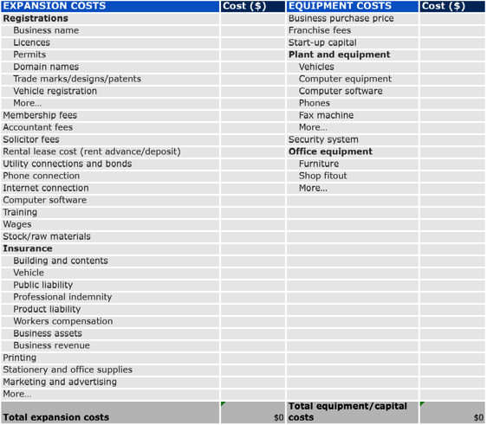

Balance sheet forecast

Double-click the table below to enter your details or attach your own Balance sheet forecast at the back of this business plan

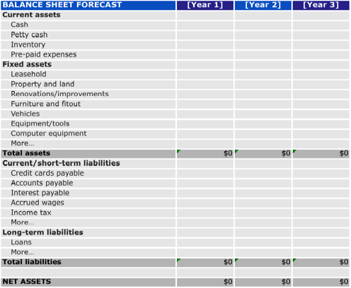

Profit and loss forecast

Double-click the table below to enter your details or attach your own profit & loss sheet at the back of this business plan

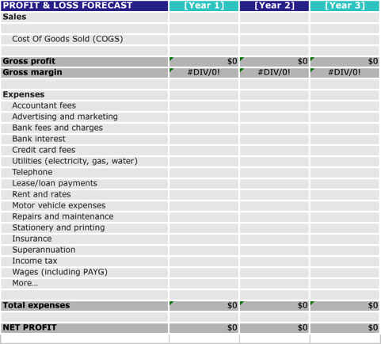

Expected cash flow
[Double-click the table below to enter your details or attach your own expected cash flow sheet at the back of this business plan]

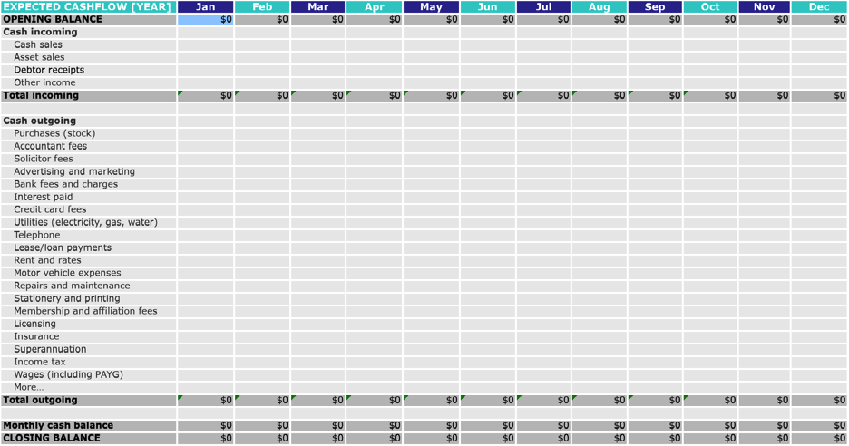

Break-even analysis

[Double-click the table below to enter your details or attach your own table]

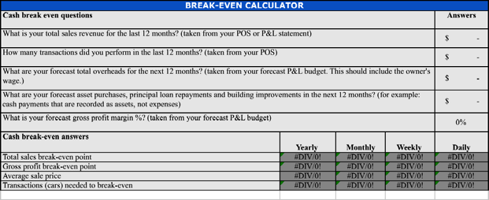

Supporting documentation

Attached is my supporting documentation in relation to this business plan. The attached documents include:

- List all of your attachments here. These may include resumés, inventory list, survey/questionnaire and/or financial documents.

